Yuma County fair queen lady-in-waiting contest
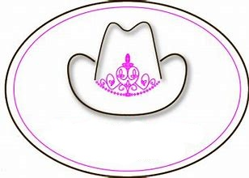
  - Deadline Thursday, July 29, 2021 by 5pm
Yuma County Fair &
Rodeo Royalty
Checklist Needed to apply
- Fill out the application in full
- 2 Letters of Recommendation
- Signed Liability Waiver
- Written Essay
- Contest Date: Thursday, August 5th @ 9:00am
- Location will be North Side of the Rodeo Arena

- There will be a few practice sessions with the current royalty/coordinators- this will be you chance to ask as many questions as you can. We will let you know when practice days will be.

**Contact Queen Coordinator Michelle Smith for Application and Handbook**
Michellesmith010@gmail.com
Cell: 970-630-5868

Application also available on the Yuma County Webpage
https://yumacounty.net/county-fair/royalty/

